**UID LAB EXP 6  
UI Design Lifecycle Using RAD Model for “COOKCRAFT” Interface**  
 Student: Sanjay Kishan D  
 Register Number: 230701287

**UI Design Lifecycle Using RAD Model**

**Project: "CookCraft" – A Recipe Sharing & Meal Planning App Interface**

**Aim**

To demonstrate the application of the Rapid Application Development (RAD) model in designing the UI for "CookCraft", a recipe sharing and weekly meal planner app. This project showcases each stage of the UI design lifecycle through rapid prototyping and feedback, targeting an intuitive and efficient cooking inspiration experience**.**

**Simulating the Lifecycle Stages Using the RAD Model**

**The RAD model is used to iterate quickly through the following stages:**

**1. Requirements Planning**

**Objective:  
To define the core structure, key user needs, and must-have features of the CookCraft app.**

**UI Structure and Feature Analysis:**

* **Top Navigation Bar:** Includes options like Home, Discover, Meal Plans, Favorites, Search, and Profile.
* **Hero Banner:** Highlights trending recipes and a CTA like “Plan Your Week” or “Explore Recipes”.
* **Recipe Cards:** Show image, title, prep time, and rating.
* **Meal Planner Module:** Weekly calendar layout for drag-and-drop recipe scheduling**.**
* **Search & Filters:** Search by cuisine, prep time, dietary type (vegan, keto, etc.).
* **Login Modal**: Clean 0055I with email/password and social login options.

**2. User Design (Prototyping with Axure RP)**

**Tool Setup:  
Create a new project in Axure RP:  
Project Name: CookCraft UI Design**

**Page Breakdown:**

**a. Homepage**

* Top Navigation
* Hero Section (with action button)
* Trending Recipes Carousel
* Footer: Contact, Social Media, App Download

**b. Discover Page**

* Recipe Grid View
* Filter Sidebar (Cuisine, Diet, Time, Rating)
* Pagination or Infinite Scroll

**c. Meal Planner Page**

* Weekly Grid Layout
* Drag-and-Drop Recipes
* Add Note/Reminder Button

**d. Recipe Detail Page**

* Image Banner
* Ingredients List
* Step-by-step Instructions
* Buttons: Save to Favorites, Add to Meal Plan

**e. Login/Signup Modal**

* Fields: Email, Password
* Social Login Options (Google, Facebook)
* "Forgot Password" Link

**Wireframing & Prototyping Steps:**

* Create reusable components (Navbar, Recipe Card, Footer)
* Add interactions: hover effects, click transitions, drag-and-drop behavior
* Link all pages for seamless navigation
* Annotate elements with padding, font hierarchy, and responsive behavior

**3. Construction**

**Interactive Prototyping in Axure RP:**

* Use dynamic panels for drag-and-drop in meal planner
* Simulate filters, save actions, and recipe previews
* Apply a visual style guide with warm earthy tones, serif fonts, and icons
* Transitions: Slide for pages, Fade for modals

**Functionality Simulated:**

* Recipe card click opens detail page
* Add to meal plan via drag-and-drop
* Modal pop-ups for login and recipe saving
* Responsive layout toggles for mobile view

**4. Cutover (Testing and Feedback)**

**User Testing:**

* Share prototype via Axure Cloud
* Conduct usability testing for:
  + Meal planner interaction clarity
  + Recipe browsing and filtering
  + Navigation between pages

**Feedback Focus:**

* Are buttons intuitive and visible?
* Does drag-and-drop feel responsive?
* Is mobile usability consistent?

**Iteration Steps:**

* Refine drag sensitivity in the planner
* Improve color contrast and font sizes
* Add tooltips and hover feedback
* Optimize layout for mobile breakpoints

**5. OUTPUT**

**a. Login Page**

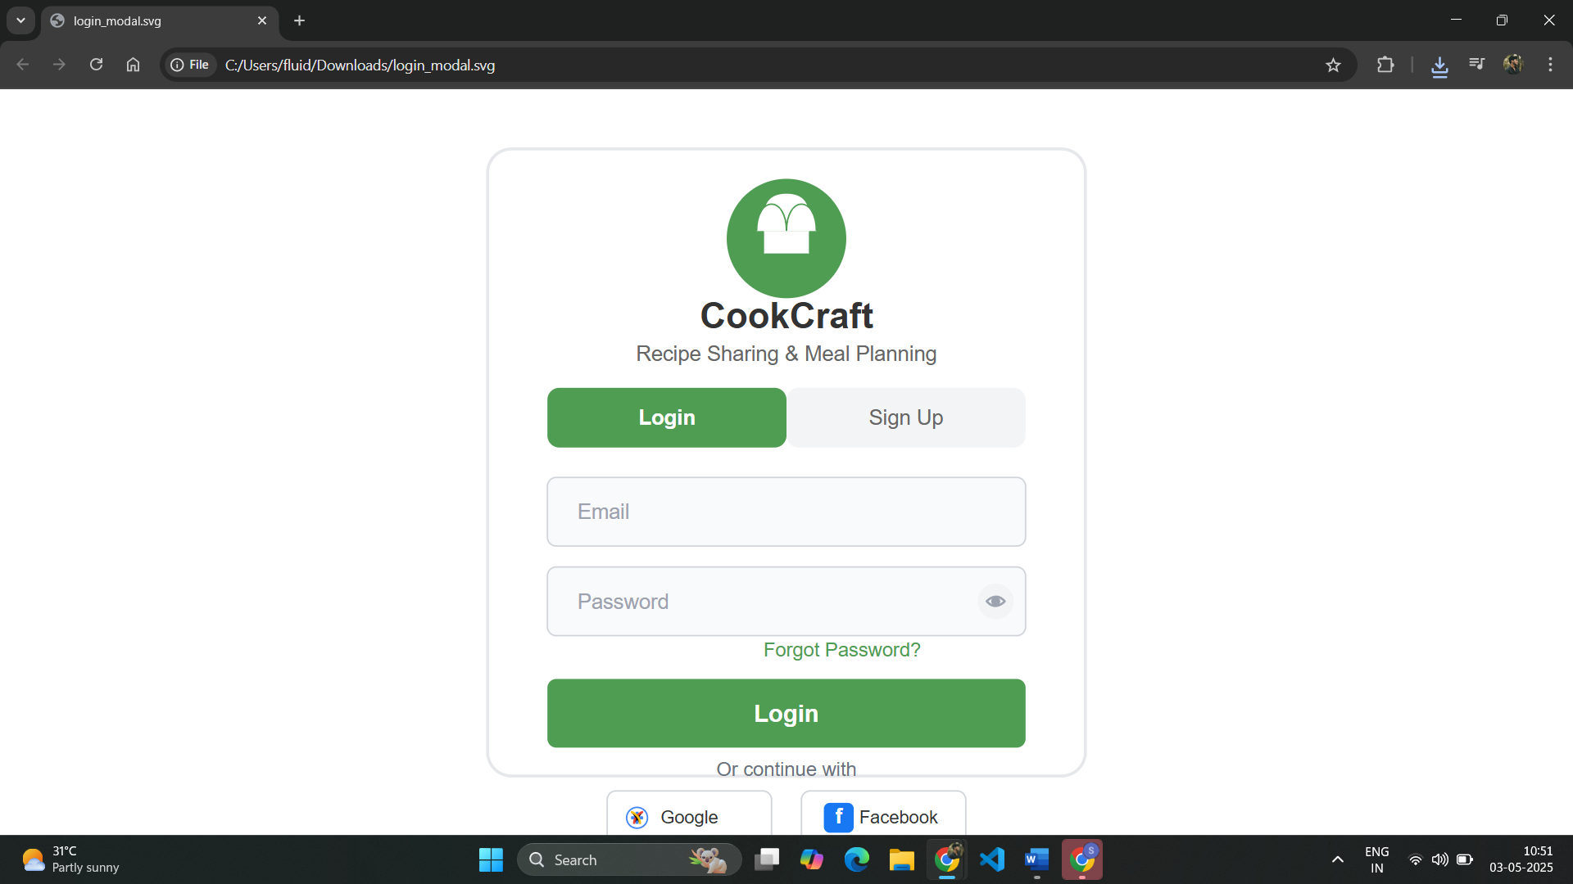

**b. Home page**

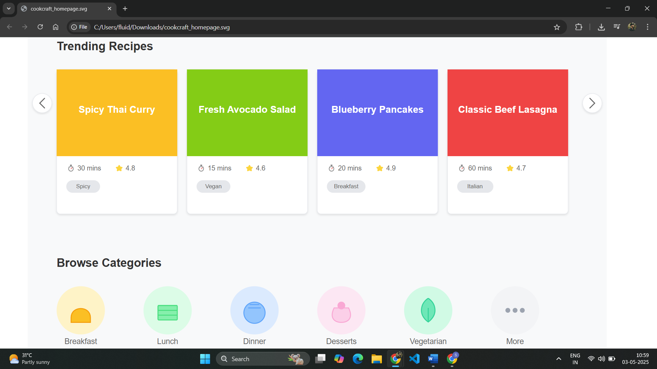

**3. Meal Planner** 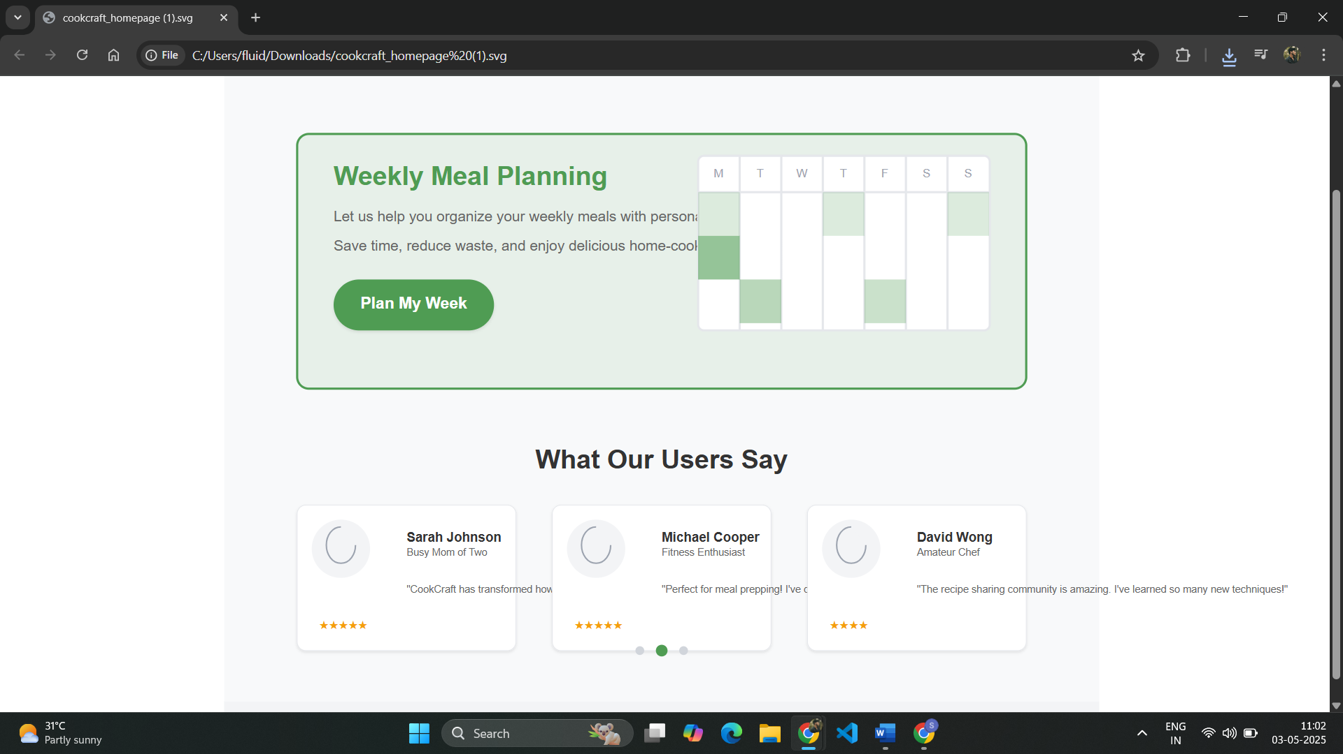

**Conclusion**

The UI design lifecycle of "CookCraft" guided by the RAD model ensures fast, user-centered design through iterative prototyping and testing. The result is an engaging and efficient recipe-sharing interface that aligns with real user behaviors, ready for transition into a full-stack solution.